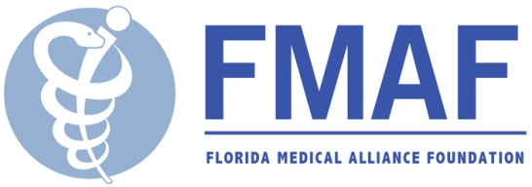

**Disaster Relief Fund**

**Grant Application**

The Disaster Relief Fund provides financial assistance to individuals or community health-based non-profit organizations after a natural or man-made disaster. Applicants may be recommended by an FMA Alliance County or FMA Alliance Individual Member. Grants up to $1,000 will be considered.

Date

Person completing application: __________________________________________________________

Phone: _____________________________________Email: _________________________________________

**Application on behalf of an individual:**

Name Address Phone Email

**PLEASE ANSWER A, B, C BELOW**

**Application on behalf of an organization:**

Name of organization Mailing address Phone Fax Email Website _ Contact person/position Mission statement:

_

_

_ Is the organization a 501(c)(3)? _ If YES, please provide IRS documentation.

**PLEASE ANSWER A, B, and C**

1. Describe the disaster with date, type, location, and any other pertinent facts.

_

_

_

_

_

_

1. List in detail the needs created by this disaster that can be met through this fund.

_

_

_

_

_

_

1. Please itemize the amounts needed to meet your recovery needs.

_

_

_

_

_

_

Please send applications to: Email: [info@myfmaa.org](mailto:info@myfmaa.org)

Mail: Florida Medical Alliance Foundation PO Box 353

Winter Park, FL 32790

*The Florida Medical Alliance Foundation is a non-profit charitable organization that works to advance medicine and public health by providing philanthropic support for health- related initiatives throughout the State of Florida.*